**LASSO, RIDGE & ELASTIC NET REGRESSION**

**Business Problem** = ﻿﻿ ﻿Perform the Lasso and Ridge Regression to Predict sales Price of the computer.

* **Name of the File: -** Computer_Data.csv
* **Size of the File: -** 253 KB
* **Data: -** 6259 Observation, 10 Variable
* **Column Name: -** price, speed, hd, ram, screen, cd, multi, premium, ads ,trend

**Exploratory data Analysis** =

* **Outliers: -**  yes outliers are presents.
* **Missing Value: -** Data don’t have Missing Values
* **Normality: -** Data are not normal
* **Transformation: -**  May be Required to improve accuracy

**Scatter plot =** From below scatter plot we can say that there are not have any strong correlation

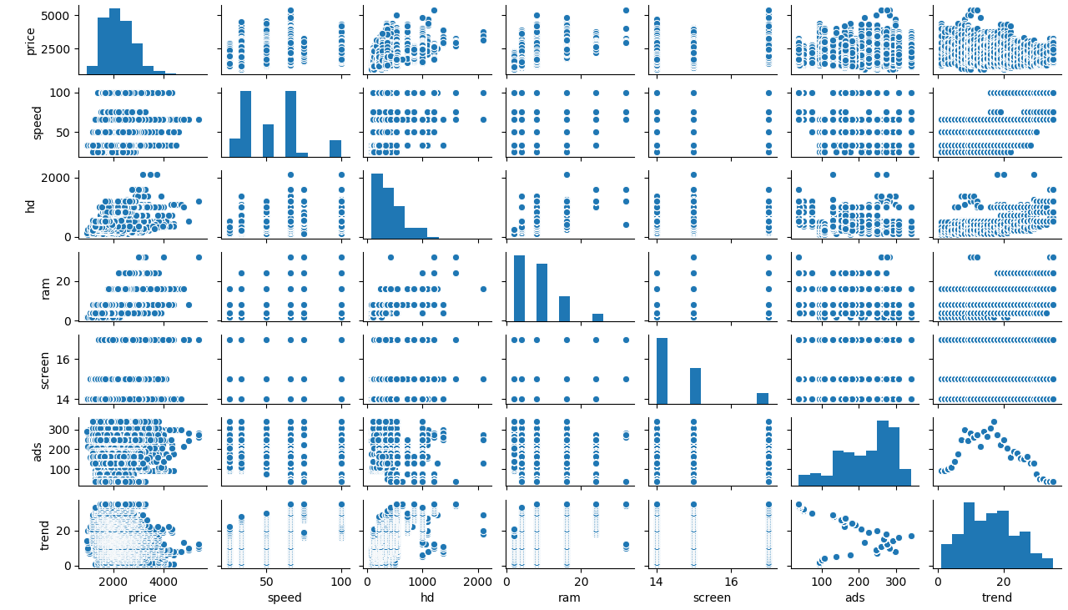

**Correlation Coefficient (r) =**  Correlation between price and ram is having moderate correlation and all other having weak correlation

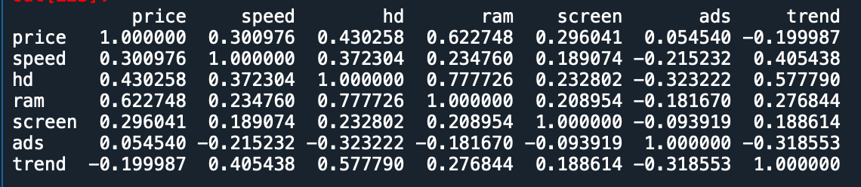

**Building Lasso Model =**

* **Scatter Plot for Selection of Perfect Lambda value : -**

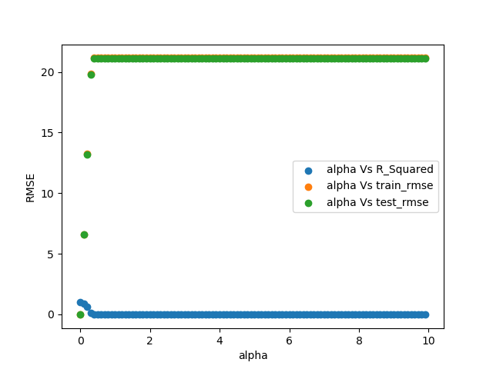

**Accuracy =** Building model by selecting optimum value of Lambda i.e. 0.01 by help of the above plot. Accuracy given by model as follows.

* **R2 : -** 99%
* **Train RMSE : -** 0.66
* **Test RMSE :** - ﻿0.66

**Important Coefficient Plot =**

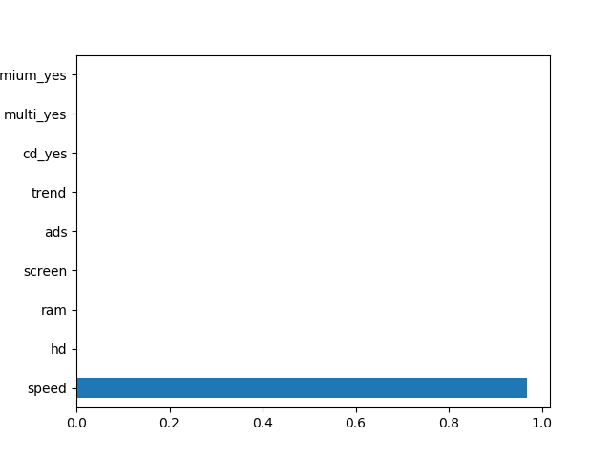

**Building Ridge Model =**

* **Scatter Plot for Selection of Perfect Lambda value : -**

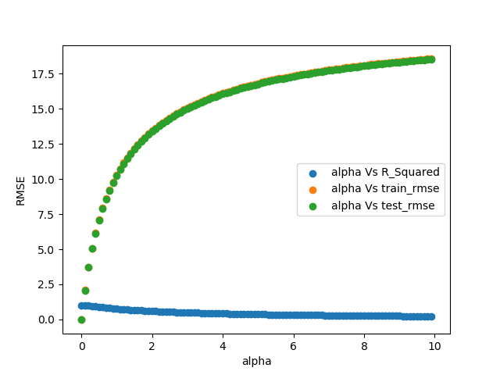

**Accuracy =** Building model by selecting optimum value of Lambda i.e. 0.01 by help of the above plot. Accuracy given by model as follows.

* **R2 : -** 99%
* **Train RMSE : -** ﻿0.23
* **Test RMSE :** - ﻿0.23

**Important Coefficient Plot =**

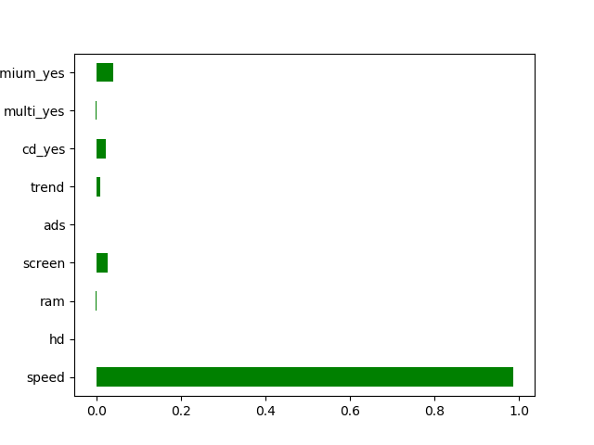

**Building Elastic Net Model =**

* **Scatter Plot for Selection of Perfect Lambda value : -**

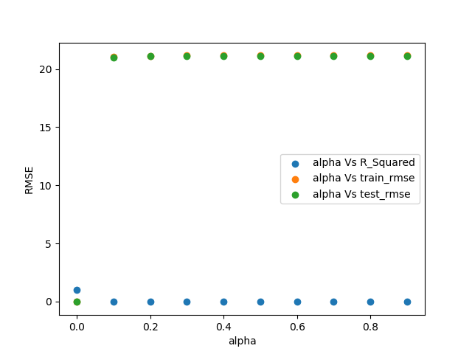

**Accuracy =** Building model by selecting optimum value of Lambda i.e. 0.0001 by help of the above plot. Accuracy given by model as follows.

* **R2 : -** 90%
* **Train RMSE : -** 0.5
* **Test RMSE :** - 0.5

**Important Coefficient Plot =**

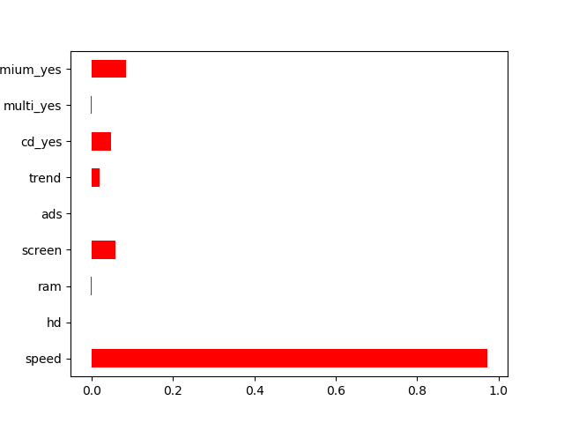

Form Above Three model Ridge is giving us best result so we can be use it for future prediction

**Python code file**: - [Computer data Lasso and Ridge Analysis.py](https://github.com/nilaydeshmukh0/Lasso-Ridge-and-ElasticNet-Regression-With-EDA/blob/master/Computer%20data%20Lasso%20and%20Ridge%20Analysis/Computer%20data%20Lasso%20and%20Ridge%20Analysis.py)